**Website Planning Document**

**Rain Today?**

*Author: Tamlyn Laurence*

**Site Purpose**

Rain Today is a website that people from Franklin, Greenville, and Springfield areas can use to find out if the day will include rain so that they can adjust their plans accordingly.

**Target Audience**

Adult residents and visitors to Franklin County.

**Site Map**

osu\ 
uvăue 
KB\e9 
o;uł 
jawa) 
ppł$uvdS 

**Color Scheme**

The color scheme for Rain Today is muted but sophisticated for adult visitors. They are after information, not color entertainment.

*t24655E 
*4ЗД165 
*6С7СЗО 

|  |  |  |  |  |
| --- | --- | --- | --- | --- |
| Crème  Main Body | Dark Teal  Nav Bar  Bottom Bar | Light Teal  Events and Alerts box | Lime  Header | Olive  Background behind body |

**Typography**

The primary text fonts are Roboto Condensed Bold and Raleway Regular

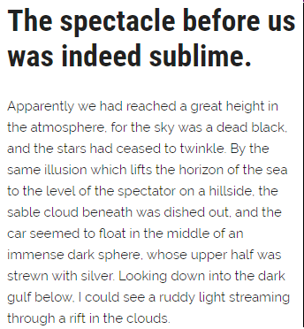

**Roboto Condensed Bold**

*(White on dark or light teal)*

* Header
* Headings

**Raleway Regular**

*(Black on cream)*

* Events and Warnings
* All data

**Icons**

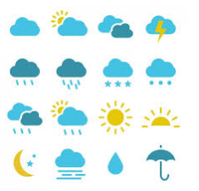

**Wireframe Sketches**

|  |  |
| --- | --- |
|  |  |
|  | |